Spanish I Unit 4 Benchmark Assessment
Nombre__________________________ fecha___________________________
Listening Assessments
- Listen to the following conversations between community members and answer the questions based on what you hear.
(Listen to conversation 1)
- The conversation is most likely taking place in:

- Un club de baile
- Una iglesia
- Una tienda de ropa

- For what occasion is the customer shopping?
- A job interview
- A wedding
- A family cookout
- Why does the clerk recommend a blue dress?
- The customer’s favorite color is blue.
- The customer’s best friend likes blue.
- The clerk says that blue is perfect for this season.
(Listen to conversation 2)
- Where is this conversation most likely taking place?

- In a church
- In a museum
- On a street

- What is happening during this conversation?
- A person is asking for and getting directions.
- A person is ordering food from a restaurant.
- A person is shopping.
- ¿Dónde está el museo?
- El museo está a la derecha del banco.
- El museo está en la calle San Miguel.
- El museo está cerca de la biblioteca.
(Listen to conversation 3)
- This conversation is taking place….

- On the phone
- In person
- In an email

- What type of relationship do the two people in the conversation most likely have?
- They are cousins
- They have never met before this conversation.
- They are friends.
- What does Mari have to do before going to the dance?
- Mari has to study for a history test.
- Mari has to go to her grandmother’s birthday party.
- Mari has to eat dinner in a restaurant with her grandmother.
- You are in Spain, listening to the radio while taking a taxi from one location to another. Listen to the commercials/announcements and answer the questions based on what you hear.
(listen)
- What type of event is mentioned in this announcement?
- A sale in a clothing store
- A soccer game
- A concert
- What type of discount is mentioned?
- All callers will get 2 free tickets.
- All callers will get a free ticket.
- All callers will get tickets at 50% off, and the first caller will get 2 free tickets.
- How can the listeners get tickets?
- You can get tickets by calling the radio station.
- You can get tickets by going to the stadium.
- You have to send the radio station an e-mail to get tickets.
(Listen)
- Who is the target audience of this advertisement?
- Families with small children
- Grandparents
- People of all ages
- Which of the following activities could you do at the club?
- Play videogames with family and friends
- Use the internet
- Study English or French
- When is the club open?
- On the weekends
- Monday through Friday
- During the school day

Reading Assessments
- According to the description you read, label the parts of the neighborhood where they should go.

SUPERMERCADO

El museo está a la izquierda del supermercado y en frente del colegio. El gimnasio está al lado del colegio que está a la izquierda del kiosco. El parque está en el centro del vecindario.
- Answer questions based on what you read.
FIESTA DE LA JUVENTUD
El sábado 22, durante todo el día, el pueblo de Alcalá celebra la Fiesta de la Juventud en el vecindario Intermunicipal. Se alternan entre el pueblo y la playa; exhibiciones, competencias de deportes, juegos tradicionales y más. Todas las actividades son de participación libre y gratuita. Todos los niños entre 6 y 18 años pueden participar.
- Who may participate in these events?
- Parents
- College students
- Children
- What type of activities can participants do?
- Sport/athletic competition
- Arts and crafts
- Book readings/Story telling
- Answer the questions based on the following dialogue.
- Buenas tardes señores. ¿Algo para beber?
- Quiero un café con leche.
- ¿Y para usted?
- A mí me gusta la coca cola.
- Y, ¿Para comer?
- Dos órdenes de tacos de carne asada, por favor.
- ¿Algo más?
- No, gracias.

- ¿Dónde están los señores?
- en el museo
- en el colegio
- en un restaurante

- ¿Qué van a comer?
- café con leche
- gustaria
- tacos

- Probablemente, ¿qué hora es?
- Son las siete de la mañana.
- Es el mediodia.
- Es la una de la mañana.
- Say whether each statement is true or false based on the following e-mail correspondences.
(Linda’s e-mail to Carina)
Carina!
¿Cómo estás? Yo estoy bien. Esta semana tengo que prepararme para un exámen muy difícil de la clase de matemáticas. Voy a pasar una hora cada día en la biblioteca después de clases. También, tengo que practicar la guitarra para mi concierto el domingo. ¿Vas al concierto? Bueno, ¡ojalá que sí!
Nos vemos amiga,
Linda

(Carina’s response to Linda)
Hola Amiga,
¿Qué tal? Yo, bien, pero muy ocupada. Voy a pasar ésta semana con mis tíos y mi prima Raquel. Ellos son judíos, entonces vamos a ir a la sinagoga el jueves y el sábado. Como siempre, tenemos que hacer la tarea y estudiar todos los días después de las clases. Tengo el entrenamiento de basquetbol el lunes y miércoles, y tengo un ensayo de la clase de teatro el viernes. Pero el domingo, no tengo que hacer nada, entonces si voy a tu concierto.
Un abrazo,
Carina

- Linda will be spending the week with her cousin.
- Carina will be attending the synagogue with her cousin.
- Both girls will be studying.
- Both girls will be playing a sport.
- Linda and Carina will be seeing each other on Sunday.
Writing Prompt 1
You are planning a surprise party for your best friend this weekend. You want the party to take place at the dance club that is across the street from your school. Leave a phone message for a friend to invite them to the party. Include the following information:
- Who/What the party is for
- Where the party will take place
- The time and date of the party
- How to get to the dance club from school
________________________________________________________________________________________________________________________________________________________________________________________________________________________________________________________________________________________________________________________________________________________________________________________________________________________________________________________________________________________________________________________________________________________________________________________________________________________________________________________________________________________________________________________________________________________________________________________________________________________________________________________________________________________________________________________________________________________________________________________________________________________________________________________________________________________________________________________________________________________________________________________________
Writing Prompt 2
You are living and studying in a small village in Southern Spain for a semester. While you are there, a friend is coming to visit you but you have an exam and cannot meet him/her upon arrival. Write an email with a set of directions to a meeting place for you and your friend. Write the instructions to help your friend get from the train station (A) to your house (B). Follow the path shown.

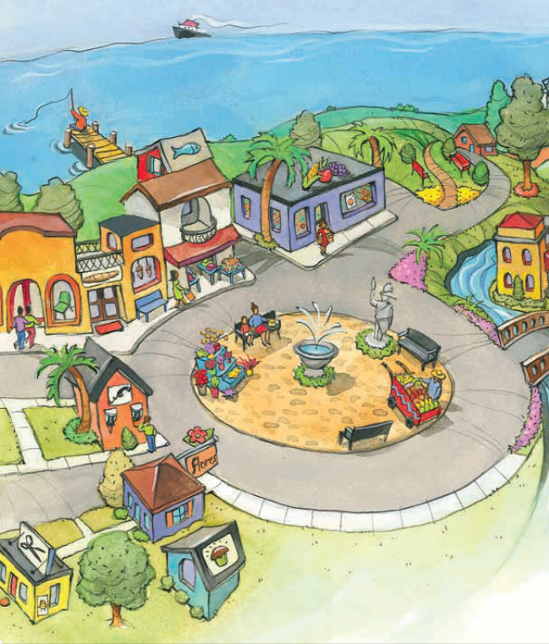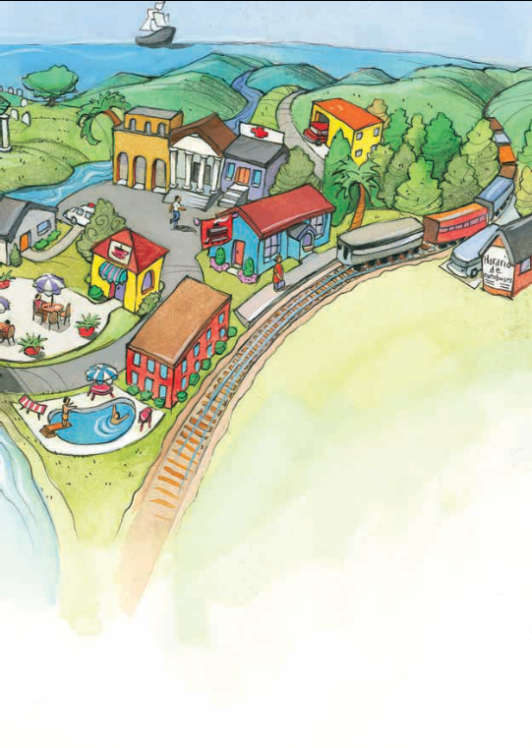
A
B B
____________________________________________________________________________________________________________________________________________________________________________________________________________________________________________________________________________________________________________________________________________________________________________________________________________________________________________________________________________________________________________________________________________________________________________________________________________________________________________________________________________________________________________________________________________________________________________________________________________________________________________________________________________________________________________________________________________________________________________________________________________________________________________________________________________________________________________________________________

